1. **HOW TO CREATE AN AWS LAMBDA FUNCTION USING AWS CONSOLE**
2. Search Lambda in AWS search bar
3. Click on Lambda
4. Lambda home screen opens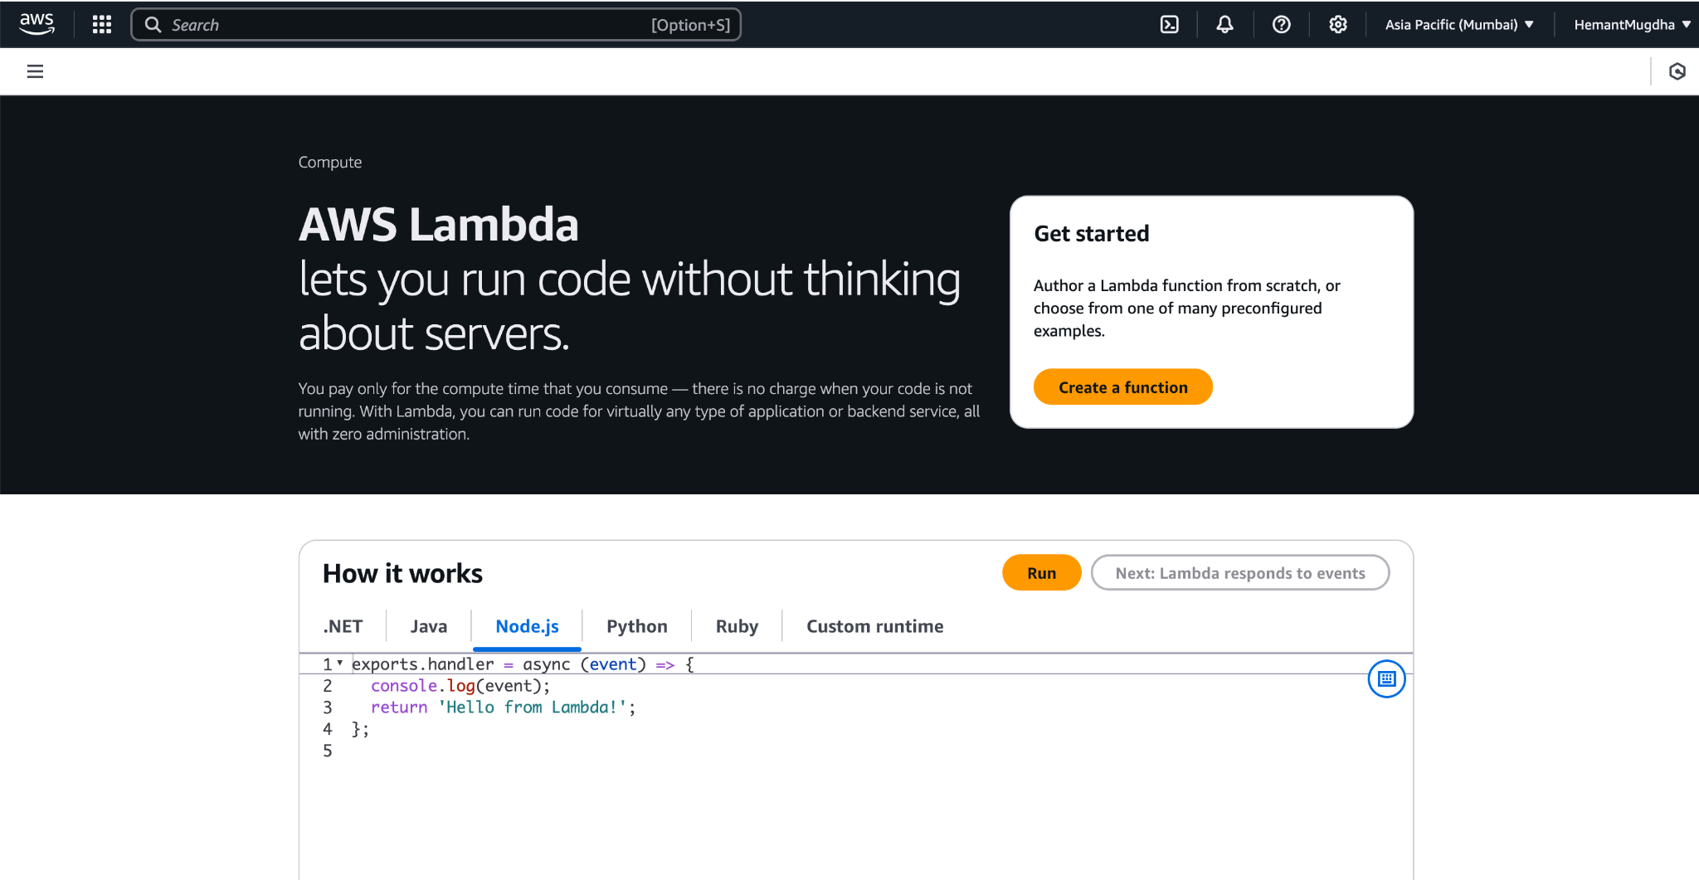
5. Click on **Create a function**
6. Provide **Function name >> Select Runtime(You can select one which you are comfortable coding in )**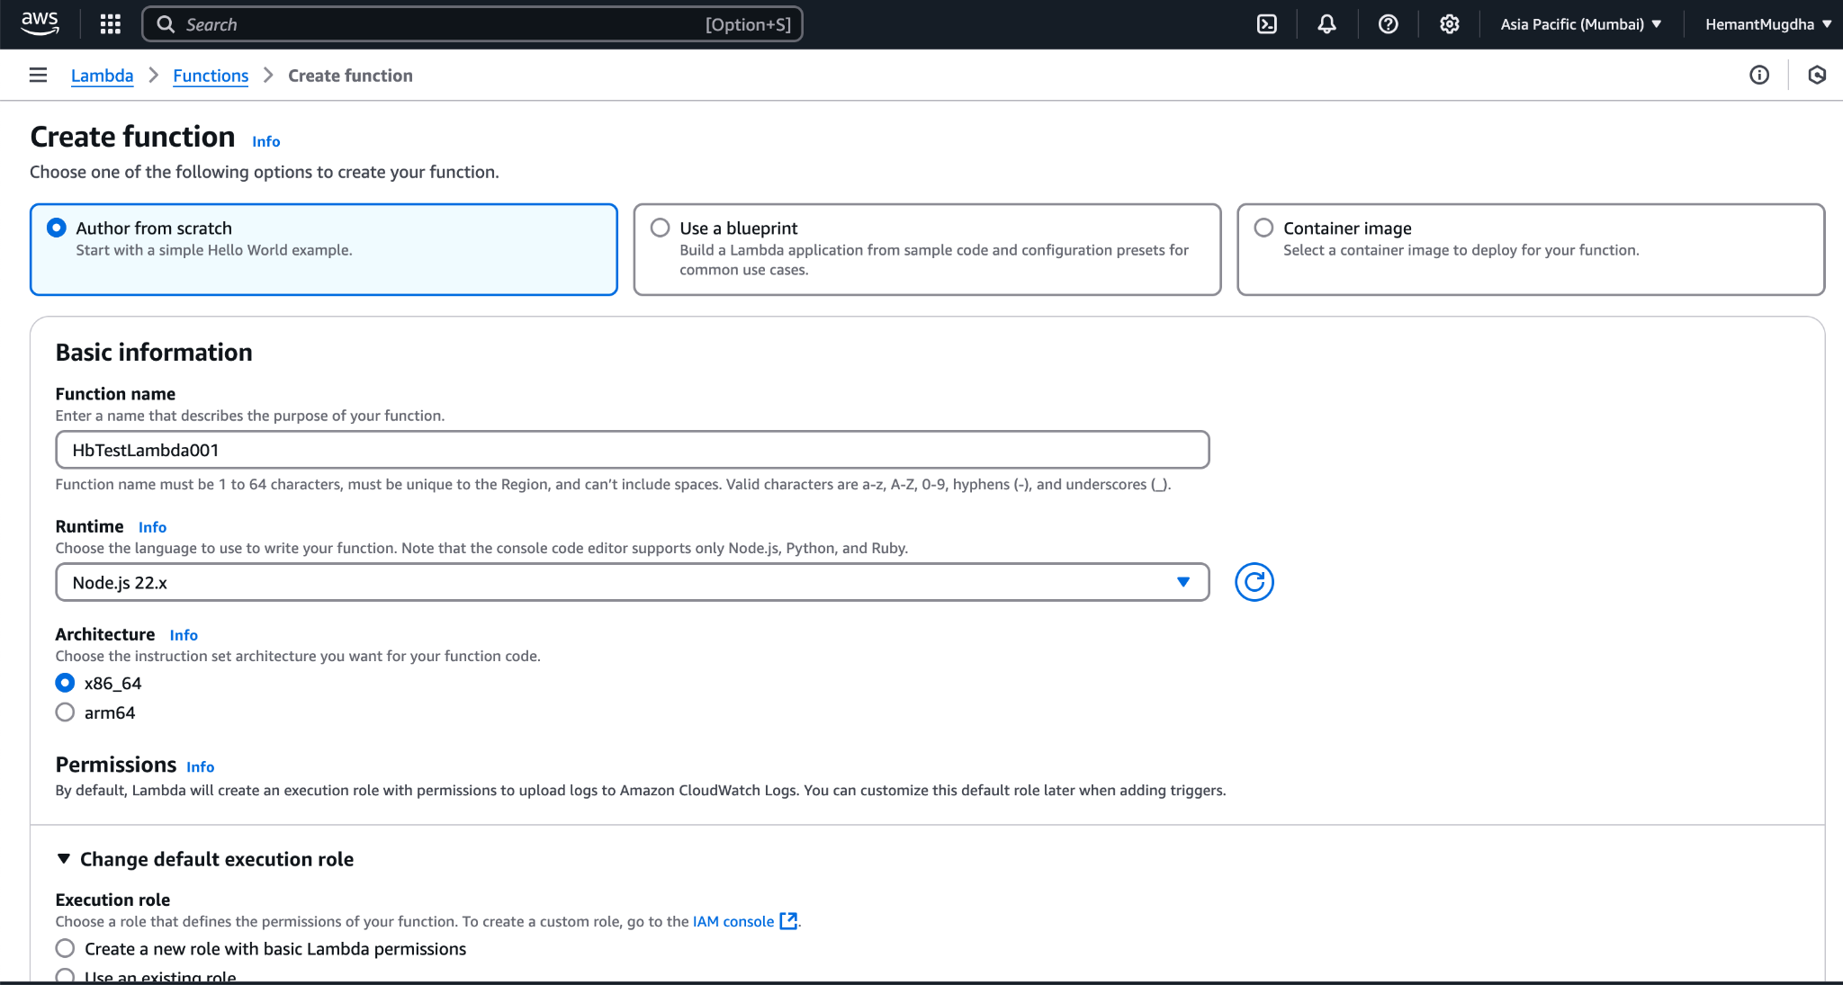
7. Choose to **Create a new Role with Basic Lambda Permissions(This creates role with all minimum required permissions and attaches to Lambda automatically)**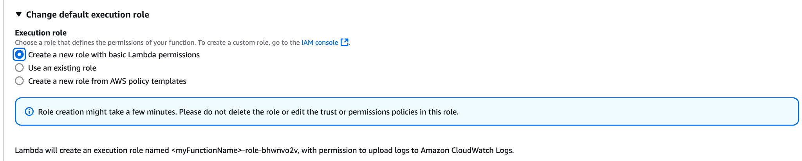
8. Click on **Create Function**
9. On successful creation, following screen shows up.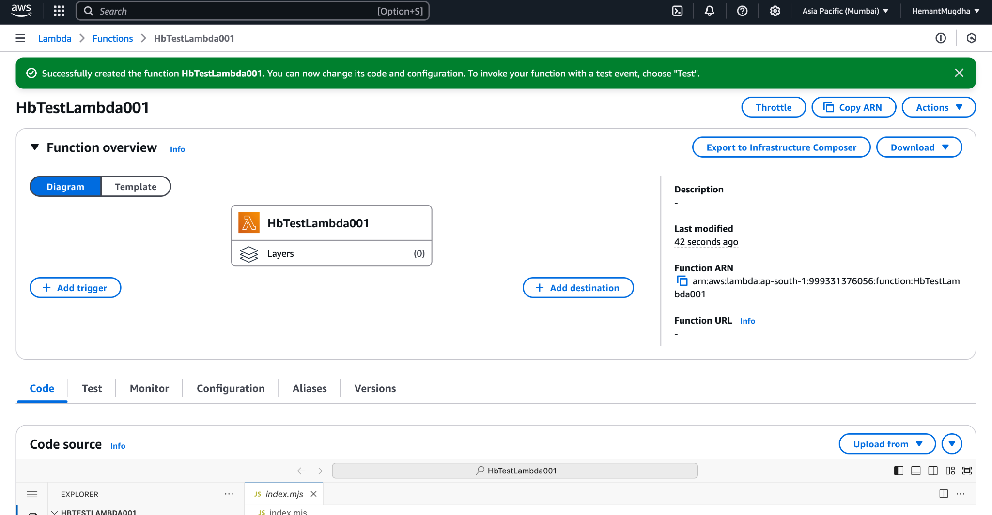
10. Open **Code** tab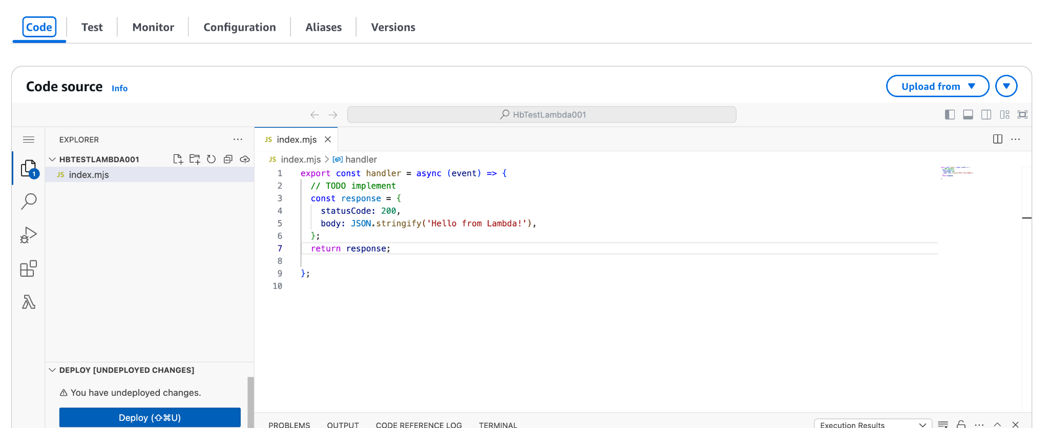
11. Keep the code as it is >> Open **Test Tab** >> Click on **Test** button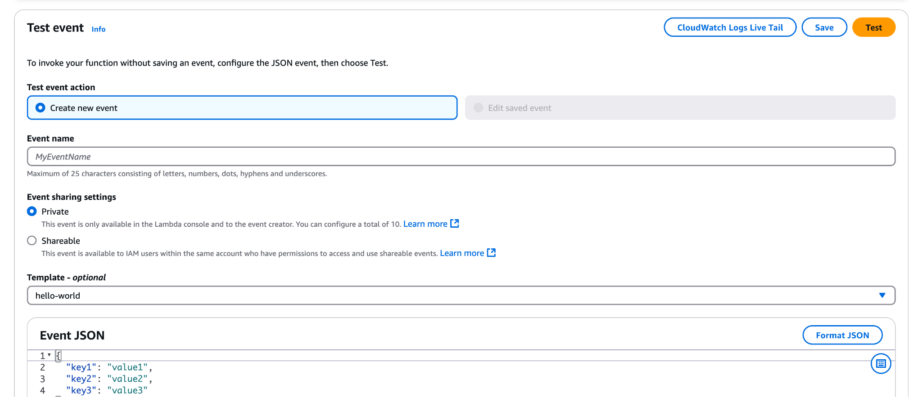
12. On successful run of **Function**